TCCR JUNIOR GOLF REGISTRATION

Search the following web address in your browser to register your child in MyGolf Term 1 2024 program at Thurgoona Country Club Resort.
STEP 1 https://www.golf.org.au/mygolf/home/

STEP 2 Click on ‘Find Your Local Program’.
Click ‘Centre Name’ and type Thurgoona Country Club Resort.
Click ‘Find A Program’
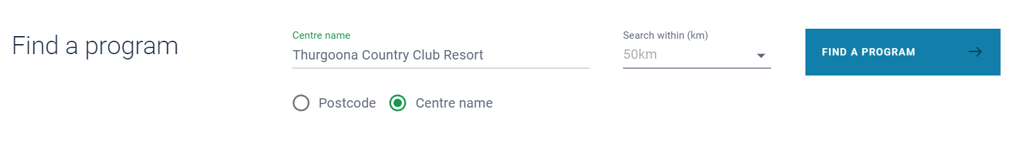
STEP 3 Scroll to bottom of page below the map and click ‘VIEW PROGRAMS’
You can then register your child in the Term 1 2024 program from 04/02/2024 – 14/04/2024 by clicking ‘REGISTER’

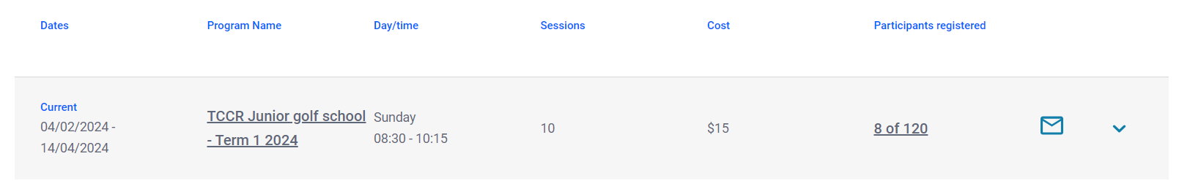

Please also join the TEAM APP 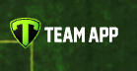 and search ‘THURGOONA GOLF CLUB JUNIORS’ for all the latest correspondence. All updates and news regarding the program will be via TEAMS once your child has registered.

On your smart device, search the app store for TEAM APP and click Install. All correspondence for the Junior golf program will be via this platform so please check for update before ringing the Pro Shop.

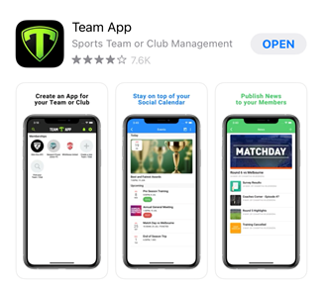

Once you have Installed the app, search ‘Find your Team / Club’ for Thurgoona Golf Club Juniors.
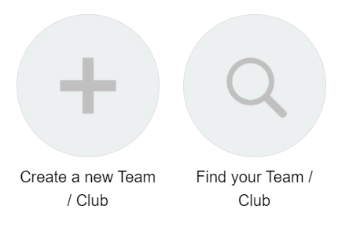

Click on Thurgoona Golf Club Juniors and Request to join this teams app.

Remember to check this app regularly for any news, events, schedules, and photos. We look forward to welcoming new and existing junior members. Happy Golfing and remember to have fun…..

